On The Market Salesforce Integration
Version 1.0 | 6/23/2025

Grainger
Statement of Work

Contents
1. Statement of Work 3
1.1 Overview 3
1.2 Solution Overview 3
1.2.1 Listing and De-Listing of Units 3
1.2.2 Capturing Leads in Salesforce 3
1.3 Objectives 5
1.4 Delivery Approach 5
1.4.1 UAT 5
1.4.2 Production Support 5
1.5 Responsibilities 5
1.6 Availability 6
1.7 References 6
2. Assumptions, Exclusions & Limitations 7
2.1 Assumptions 7
2.2 Exclusions 7
3. Cost and Timelines 8
3.1 Costs 8
3.2 Timeline 8
3.3 Extension of Service Period 8
4. Acceptance 9
- Statement of Work
- Overview
Grainger is in the process of engaging with “On the Market” (OTM), a third-party solution that allows prospective tenants to see available units and new developments across the entire Grainger portfolio as well as register their interest in a unit or development by completing a form on the website.
This project will allow Grainger Salesforce to initiate the listing and delisting of units on OTM directly from within Salesforce. This functionality leverages OTM’s sendpropertydetails and removeproperty Real Time Datafeed API endpoints, ensuring a seamless and efficient way for users to manage property availability without leaving the Salesforce environment.
This project will also allow prospective tenant details submitted to OTM to be captured as Leads in Salesforce so that the Lettings team can then follow the existing qualification and conversion process.
- Solution Overview
The proposed solution would contain the following key features:
    - Listing and De-Listing of Units
- Use of the OTM Real Time Datafeed API which mirrors the Rightmove Real Time Datafeed API already in use by Grainger

- Functionality developed within Salesforce, initiated by clicking a button on the Unit record page, to send a JSON payload from Salesforce to the OTM sendpropertydetails API that contains details of selected unit.
  - Unit details will consist of unit, building and block (estate) data including features.
  - Unit details will additionally include URLs of images and documents (such as floor plans, EPCs and 360 tours).
  - Approximately 30 unit attributes will be passed to the API.

- Functionality developed within Salesforce, initiated by clicking a button on the Unit record page, to send a JSON payload from Salesforce to the OTM removeproperty API to remove a Unit from the OTM listing

- Error handling for both the listing and de-listing of units
    - Capturing Leads in Salesforce

- Depending on OTM’s capabilities, prospective tenant details will be:

  - Sent directly by OTM to a Salesforce custom email service which will process the incoming email to create a new Lead record as per Figure 1 below. This is the preferred option as it allows for minimum delay between the prospect submitting an enquiry and receiving the follow up email sent in 3 below.

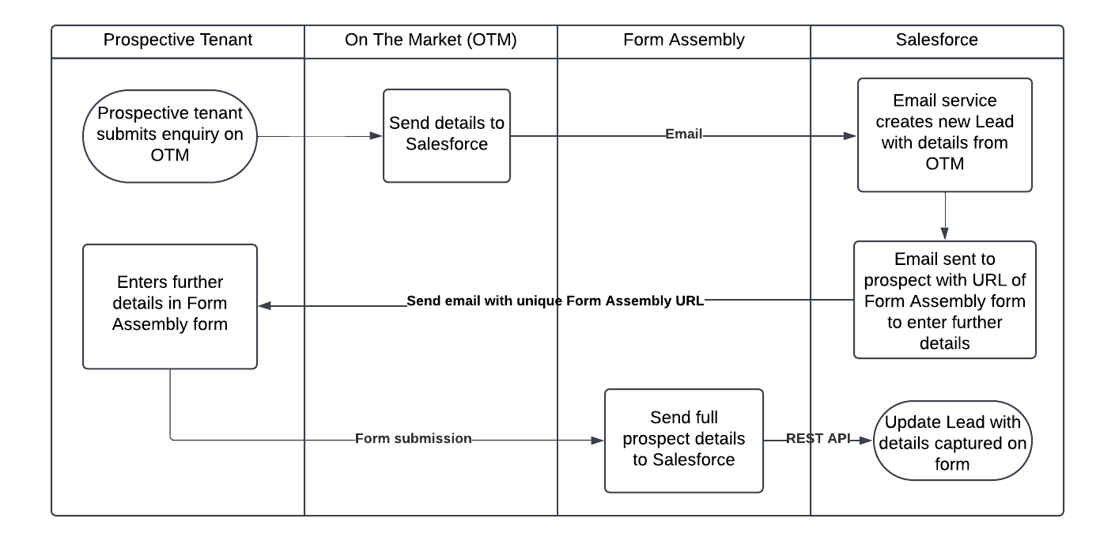
Figure 1 - Lead Creation via Email Service
OR
  - Retrieved from the OTM getbrandemails or getbranchemails API endpoints via a scheduled Apex batch process running on Salesforce as per Figure 2 below. This option introduces latency of 15 minutes or more (depending on the batch frequency) between the prospect submitting an enquiry and receiving the follow up email sent in 3 below.

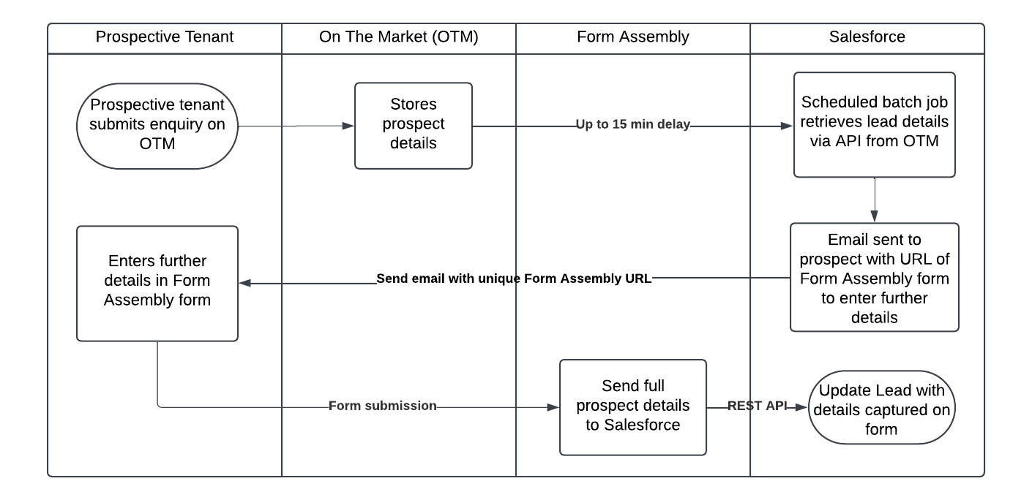
Figure 2 - Lead Creation via Polling of OTM API

- The new Lead will be assigned to a “holding queue” while it waits for enriched prospect data to be captured.

- On creation of the new Lead record, an automated email will be sent by Salesforce to the prospective tenant with the URL of a Form Assembly form. The Lead Id will be passed as a secure URL parameter to uniquely link the prospects’ form to the corresponding Lead record in Salesforce.
- The Form Assembly form above will present the prospect with a questionnaire to capture the same details as are currently captured by the existing Rightmove questionnaire (https://graingerplc.co.uk/forms/15)

- When the prospect submits the Form Assembly form, the data captured in the form will be securely sent to Salesforce to update the corresponding Lead record.

- The updated Lead will be assigned to the existing “lettings queue” where a lettings agent will follow up and progress the Lead.

- The OTM Leads will follow the existing process developed for Rightmove leads, including reminder emails and visual flags on the list view.
- Objectives
The objectives of this project are to:
- Conduct sufficient upfront analysis in order for Open Box to be in a position to commence development.

- Write user stories, with detailed acceptance criteria, for the features that are anticipated to be addressed first. Acceptance criteria will be reviewed and agreed with Grainger.

- Deliver a solution containing the key features listed in the Solution Overview.
- Delivery Approach
The delivery approach will be based on the kanban agile framework where features will be analyzed, developed, tested and delivered continuously throughout the project.
A backlog will be maintained to track outcomes to be delivered and indicate priority of these outcomes relative to each other. The backlog will be a living artifact that will evolve as Open Box and Grainger collaborate. Grainger stakeholders will have access to the backlog which will serve as the single source of truth with regards to scope.
Grainger representatives will be required to participate in backlog refinement, demos and stand-up ceremonies.
    - UAT
Grainger will be responsible for testing the functionality delivered and ensuring that the solution is performing as expected during the UAT period.
Issues raised will be classified as bugs or enhancements. Bugs will be fixed during the UAT period. Any other enhancements or new requirements will be added to the backlog for future development or addressed by extending the project timelines (by mutual agreement between Grainger and Open Box).
    - Production Support
2 Weeks of post-go-live support is provided. Future enhancements and ongoing maintenance will be managed as part of the existing Salesforce BAU Enhancements FTE agreement.
- Responsibilities
- Open Box will be responsible for:
  - Providing the services described in the project Objectives.
  - Delivering a report to Grainger on a regular basis confirming the number of hours utilized.
- Grainger will be responsible for:
  - Making an internal IT manager available to facilitate decision making.
  - Making key personnel and stakeholders available throughout the project lifecycle, including participation in the activities detailed in the Delivery Approach.
  - The configuration and stability of the UAT/staging and live environments (hardware, operating system and supporting applications).
  - Ensuring there are no other projects planned or in operation that may hinder this project.
- Availability
- Open Box resources will be contactable and available for meetings via conference calls/video conferences:
  - Monday to Friday 9am – 6pm South African time (GMT +02:00) which currently corresponds to [2am – 11am (EST)], excluding public holidays.
- A defined escalation path will be provided to the agreed project manager should urgent assistance be required outside of these times.
- All work will be completed by Open Box offsite.
  - It is not expected that the project requires Open Box resources on-site. Where onsite personnel are required, all reasonable expenses for travel and subsistence shall be reimbursed by Grainger. Open Box shall not bill any mark-up or administration fee onto any such expenses. Approval for expenses shall be obtained from Grainger prior to being incurred.
- References
- “OnTheMarket RTDF Property Lead API 2.5.pdf”
- Grainger, Open Box Meeting: OTM (19 May 2025)
- Email thread “Re: [## 1152692 ##] OTM Feed set-up: Grainger”
- Assumptions, Exclusions & Limitations
- Assumptions
The following assumptions have been made; incorrect assumptions may affect cost and timelines.
- The OTM APIs are REST APIs using OAuth authentication as per “OnTheMarket RTDF Property Lead API 2.5.pdf”.
- GREP integration is not required.
- Error handling for the API callout from Salesforce to the OTM API will follow the same mechanism as the existing Rightmove API integration.
- Open Box will deploy the functionality to Grainger’s Salesforce PROD org as detailed in the Cost and Timelines section of this SOW. The functionality may only be enabled for end users by the internal Grainger Salesforce team at a later stage once Grainger’s OTM account is live. Depending on timelines, this may occur after Production Support has ended.
- Exclusions
The following is not included in the cost or scope of this project:
- Salesforce costs, third-party costs, license fees, subscriptions or services.
- Data clean-up or data migration.
  - It is expected that Grainger will cleanse or populate any unit, building or block data in Salesforce that is required to display on the website, as necessary.
- Any API development except for what is described in the Solution Overview.
- Hardware and infrastructure.
- Solution documentation, other than user stories.
- End-user training, change management or new / updated training materials.
- Cost and Timelines
- Costs
Open Box will provide an agile delivery team to develop, test and deploy the solution on a Time & Materials (T&M) basis at a rate of £120/hour.
The team will be staffed to include the following skillsets as required:
- Salesforce Technical Architect
- Developer
- Quality Assurer
- Project Manager

The estimated effort and cost per phase are detailed below:
Phase | Hours | Lower Bound | Upper Bound
Analysis | 10 | £1 200,00 | £1 200,00
Build | 90 - 120 | £10 800,00 | £14 400,00
Project Management | 2 - 4 | £240,00 | £480,00
User Acceptance Testing | 10 - 20 | £1 200,00 | £2 400,00
Production | 3 - 6 | £360,00 | £720,00
Total | 115 - 160 | £13 800,00 | £19 200,00
Table 1: Project Phase and Costs
- Timeline
The project is anticipated to take 5 weeks to complete.
Week 1 | Week 2 | Week 3 | Week 4 | Week 5
Analysis & Build
 |  | UAT
 |  |  | Production Support
Table 2 – Indicative Project Timeline

All amounts are quoted in GBP and exclude VAT, if applicable.
The project cost will be billed monthly, in arrears, up until the completion of the final project phase. Cost will be reported to Grainger on a weekly basis. The cost will not exceed the upper limit of £19 200 without prior consultation.
Project costs will be billed monthly, in arrears.
This quotation is valid for 30 days.
- Extension of Service Period
The provision of these services may be extended, by mutual agreement between Open Box and Grainger.
Email communication is considered sufficient and binding for this purpose.
- Acceptance
The parties hereto, each acting under due and proper authority, have executed this Agreement as of the day, month and year first written below.

For and on behalf of Open Box Software For and on behalf of Grainger

Signature: _____________________ Signature: _____________________
Name: Sam Duncan Name: Jon Pitt
Position: Salesforce Director Position: Director of Lettings & Residential
Management
Date: _____________________ Date: _____________________

